

Cost Transparency using
BMC TrueSight Capacity Optimization
Ver. 9.5

2015-08-26
Ben Davies
BCOChargeback20140811d.docx

Contents
Chargeback with BMC Capacity Optimization 9.5.01 5
Introduction and Overview 5
Covering the Bases 7
Where We Started 8
Start With the End in Mind 10
Fixed Rate Cost Items 13
Allocation Based Cost Items 13
Utilization Based Cost Items 14
Before You Get Started 16
Identify the metrics you will need. 17
Workspace Tab Preparation 19
Chargeback for Projects 21
Goto The Chargeback System 21
Hierarchies 22
Cost Objects (Basic) 23
Fixed Rate – 24
Allocation - 25
Allocation VS. Utilization – 25
Utilization - 26
Cost Objects (Composite) 28
Create Cost Template 30
Create a Cost Model 31
Our Active Project Model 31
Set Cost Rates 33
Run the Model and Review Results 35
Summary of Project Chargeback System 36
Chargeback for Applications 37
Determine the basis of the heirachy 37
Create the Hierarchy 38
Cost Objects (Basic) 39
Create Cost Template 41
Create a Cost Model 43
Now Setup Cost Rates…. 44
Summary of Application Chargeback System 45
Links and Resources 46

Chargeback with BMC Capacity Optimization 9.5.01

Introduction and Overview
HCSC is using BMC TrueSight Capacity Optimization (BCO) chargeback functionality. This document is intended to document the building of the system and the decisions made. Considerable effort has been put forth over the last several years in chargeback efforts, which have laid the foundation for the effective use of a chargeback, show back, and shame back system. Some of that historical effort will be addressed shortly, but make no mistake that those efforts are vital, and without that effort, no chargeback system will be effective.
First of these efforts is cultivating the ‘appetite’ for a chargeback system. The political environment must accept this idea. Funding allocations of decree have completely different dynamics than funding based on consumption. Powerful people lose power and influence in such a shift, resistance is significant.
Deciding on a ‘cost’ for the items in a chargeback system has derailed many efforts. I submit that the cost to produce a service or item, while useful to know, ultimately does not drive the cost charged to the customer. In the business world, the price is driven by what the market is willing to pay. To the extent that price is greater than the cumulative cost to deliver the service or item, then the business can continue. When the price is less that the delivery cost, the product is eventually discontinued, or the business is. With chargeback from department to department, (where market pressures do not overtly exist) the price charged to the consumers is (should be, except for political pressure) driven by the resources consumed to create the service or item.
So if the storage group has a 12 million dollar yearly budget, or more exactly a 12 million dollar chargeback recovery target, and the chargeback system can ‘sell’ 12 million units of storage, the unit cost per year is a dollar. The fact that labor is x, disk is y, and tape is z is not all that relevant as all of that rolls up to the 12 million dollar yearly recovery target. The recovery target is somewhat independent of the storage budget.
Overcoming the difficulties in the cost of the chargeback system is difficult. Make no mistake; chargeback itself has a cost. To the extent that the cost + negative impact are greater than the perceived benefit, the chargeback system will fail. The formula is not so simple, as perceived fairness, completeness, accuracy, and repeatability are key factors in the equation. This is why funding allocation by decree have worked; while they are not very eloquent, they are perceived to be relatively fair, complete, accurate, repeatable, and cost less to execute than the perceived benefit.
BCO works as a chargeback system because the incremental cost of the chargeback component is nominal once BCO is in place provided the system instituted is sufficient to satisfy challenges to fairness, completeness, accuracy and repeatability. Our installation of BCO covers most of our physical server environment, and other environments, which satisfy these challenges (and there have been many challenges).
The ability to have groupings of chargeable items into useful entities is key. The items that are chargeable need to be attributable to a useful entity to chargeback. It is pointless to have the consumption of all resources, but then not be able to associate them to a chargeback entity. We achieve this by grouping chargeable items into projects (our chargeback effort for projects), grouping into applications (our chargeback effort for applications), and flexibility to create other groupings. This was in large part to our application portfolio management efforts over several years, AND our configuration management teams leveraging those definitions into ‘well defined’ applications. This is a huge effort that has been on its death bead numerous times. It is surprising how little consensus there is around defining what is and is not included in an application. Asking 10 subject matter experts will yield dozens of opinions of what should be included, and what should be excluded.
Mission and support. The chargeback system will need a clear, focused mission(s), and appropriate level of management support. We have found that support comes when a system can be demonstrated to provide appropriate results at a substantially reduced cost (or at a cost that is shifted away from who is doing the effort now), and are perceived as relatively fair complete, accurate and repeatable.

Covering the Bases
The appetite for the chargeback system, in this form is driven by senior executive leadership wanting to know an ‘accurate’ cost of operating an application. They went to the application portfolio management team for a cost which they provide via significant manual effort. BCO, as a newly installed product, was seen as potentially, an adequate alternative.
The configuration management team purchased BMC Atrium discovery tools at the same time as BCO. Both tools wanted to leverage the application portfolio management definitions, so when both were operational (after nearly a year of effort), it was a natural candidate to perform the application costing effort. The cost of this new mission is nominal AFTER the BMC Atrium and BMC BCO are in place with sufficient coverage.
It was decided that the costs used for project chargeback would be used for the basis on the applications. There are a limited number of items to charge for, but those metrics were sufficiently available in BCO.
As applications were discovered in Atrium based on pre existing definitions of the applications, and those applications were given to BCO with their associated devices, AND the metrics that were used in the chargeback system were facts in evidence in BCO (from the CMDB, and monitoring tools that supplied data to BCO), the process of assigning a cost was now repeatable, and therefore shown to be accurate (enough), and complete (enough) so was seen as fair (enough).
With these items in place, at great effort, application show back (mission) could be delivered to senior management (support), at minimum additional cost, with perceived fairness, completeness, accuracy and repeatability.
Here is how we did it.

Where We Started
BCO was tasked with demonstrating that it could be a chargeback system, to cost applications for senior management, then was quickly expanded to include project chargeback as a separate, independent operation, but using the same tools and techniques. You can have several, separate, chargeback systems at once in BCO. The BCO chargeback system is predicated on using a per hour charge, per resource (billable entity) and can aggregate to a per day charge, per week charge, or per month charge. Our monthly costs from our manual chargeback system will be converted to an hourly charge within BCO.
Additional use cases are seen as ‘natural opportunities’ but are not actively being pursued. The use cases are:
- Show back for applications as defined by the Atrium Discovery process. This is being actively pursued using the Atrium defined application tree.
- Charging back projects based on a manually created tree. This is being actively pursued using the Active Projects tree.
- Ad Hock chargeback of applications in the manually created application tree.
- Show back base on infrastructure tree.
- Cloud computing chargeback.
- As requested for device moves, as part of M&A activity, inventory movement, replacement budgets, etc.
Decide on the items that will trigger a charge. These need to be ‘universally’ available. So if OS is a configuration metric on all devices, you can use that to trigger an OS based allocation charge, like for the OS, normally installed agents, helper software, scripts etc. This matched the ‘per server’ charge of our existing chargeback efforts.
When you intend to charge for utilization, such as CPU use for example, the same metric name should be available for all devices. We initially attempted to use cpu_util but then realized many of our AIX devices reported as cpu_util_nmon_c. This should be accounted for in the chargeback models. You could use a different metric, create a metric combining CPU and MHz, or use other utilization type metrics. Our existing chargeback efforts used storage allocated and memory allocated, so we did as well. Note we did not use CPU consumption for servers.
BCO allows for three types of charges:
  - Fixed rate – a charge is incurred by the mere presence of an application or project.
  - Allocation – based on how much is assigned (like storage assigned, memory assigned or as a charge for generically installed software (based on OS to cover OS, agents and utilities).
  - Utilization – based on how much of a component that is actually used (like CPU utilization, memory utilization, storage utilization, etc.)

Components can either be allocated at 100% or equally shared between projects/applications, or can be assigned a formula to calculate allocation. If the component is shared between applications/projects, they will get an even amount of the charge. This is to say if there are four projects that share a component; each project gets charged 20%. If allocated at 100%, each project that has this component will be charged 100% of the component.

Start With the End in Mind
We found it helpful to ‘work backwards’ and imagine what the ‘application bill’ would look like, then define what is needed to arrive at that goal. Conceptually, we would base it on our existing manual chargeback items and rates. We wanted an overall total, and break down by application. Each application would allow some detail, such that the totals could be ‘audited’. Like this.
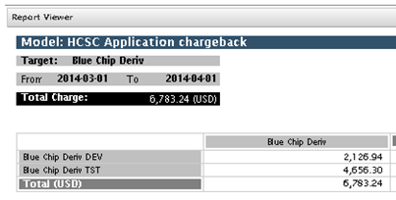

To make this work, we needed at least the existing chargeback items defined, but quickly realized that the chargeback system allowed for many more chargeable items. We added several of these choices knowing that we would end up setting the cost to 0 to compare to existing chargeback system methods.
The advantage of adding more chargeable items to the chargeback system, is that the shown cost for each item is less as the fewer implied costs are included in each item, it allows decision makers more ‘levers’ to control costs, and allows technology owners to influence consumers decisions to or away particular resource types. For example, if memory is the only resource charge for, the unit cost will be higher to include all the implied costs of the other resources consumed. I can ‘game the system’ and request more CPU and storage to compensate for ‘going light’ on memory. So if those resources are charged for as well, the cost of memory would be lower because CPU and storage are their own line items, so are not implied (not included) in the memory price, and this manipulation of the system is less beneficial. The down side of adding additional chargeable items is, ensuring universal coverage of those metrics, unintended consequences, and unintended perverse incentives.
To do effective testing we decided to use a few manually configured project groupings, rather than the automatically created application tree (with nearly 100 applications). Once complete, the tools and techniques would be ‘exactly’ the same for both the projects and applications. (So the following examples are focused on the projects but are going to be applied to application chargeback as well.)
In the end, we produced this result. This is the ‘Chargeback – Detail’ report for ‘Project A’ (there is a daily graph as part of the report, not shown). This has all the features asked for, but we have created additional detail.

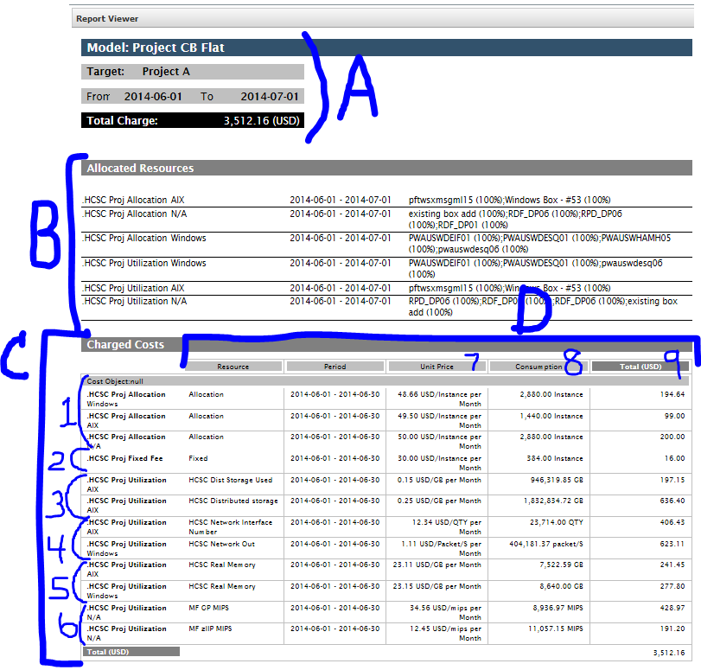
Section A is the header and shows the target project name, the period covered, and total amount. (Note the listed rates are purely contrived. Our ‘real costs rates’ were put in place after testing.)
Section B is the devices for the allocations and utilizations. This is 10 separate devices. All 10 dedicated to this project. (Note that when devices are shared AND listed as the cost is distributed then the percentage will be less than 100, and that the math is percent of hours in the billing cycle attributed to this project.)
Section C is the charged costs. When there is a breakdown in the costs those lines are represented. For example there is no zAAP resource, so section 6 does not show any.
Section D is the detail of the charges, the period covered (midnight to midnight), the unit price (note that a work factor can be applied that is not shown), the total consumption in unit hours, and the extended cost.
Consumption (8) can be normalized to an average hourly consumption number. As the listed prices are monthly prices, device by 30 (days)(the number of days in that month), then divide by 24 (hours)(or divide by 720) to give the average consumption per hour. So for the sample line, there are 2880 instance hours in column 8, divided by 720 hours in a month, equals 4 instances, times the 48.66 monthly price, equals 194.64 for that item. In the example

(2,880 / 720) * 48.66 = 194.64
4 * 48.66 = 194.64
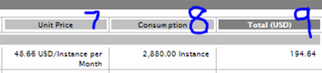

This can also be done by creating an hourly rate in Unit price (7)
Unit price (7) can be normalized to an hourly price. As the listed prices are monthly prices, device by 30 (days)( the number of days in that month), then divide by 24 (hours)(or divide by 720) to give the cost per hour. So for the sample line, the monthly cost of48.66 divided by 720 hours in a month, equals 0.0675 cents per hour, times 2880 instance hours, equals 194.64 for that item. In the example

(48.66/720) * 2880 = 194.64
0.06758333 * 2880 = 194.64

All of section 1 shows a total of 10 devices, times their respective rates, to get the total of the allocation charges for this project. Every other section (2, 3, 4, 5 and 6) does the same process. Consumption / 720* unit price.
For non-month reporting boundaries, BCO divides by the number of days in the month that the hour is in. So when you have a weekly report that has 4 days from February (a 28 day month) and 3 days from March (a 31 day month) the math gets more complicated. For a line item that is $100/month BCO figures a cost per hour for each hour then adds up the hourly costs to show on the bill.
Price / days in the month / 24 hours = price per hour * Hours = Cost for timeframe
100/28/24 = 14.88 cents per hour * 96 hours = $14.285 for the first 4 days
100/31/24 = 13.44 cents per hour * 72 hours = $9.677 for the last 3 days
Total of $23.962 for the week

After several rounds, we ended up with this as our cost items and rates (next few pages). The prices are purely fictional and were used to show that the math works, and understand how charges get applied in complex situations. The cost will be set to zero for or whatever is appropriate for any items prior to implementation. We found that charges are calculated daily, based on a chargeable item being associated with a subject application, based on item and price definitions in effect on that date. While this made comparing to our monthly hand billing system difficult, discrepancies were mostly explainable. The displayed costs are monthly (or weekly, or daily etc.) but are used by the system after converting to hourly rates.

Fixed Rate Cost Items
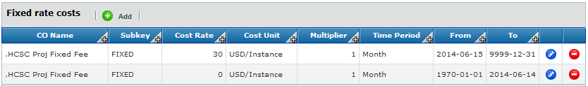
Fixed rate items are not part of the existing manual cost model, but are used here to show that we can. The fixed cost allows for the recovery of project management costs, generic application management costs etc. the idea is that every project / application pays a fee for existing. This is an interesting concept, which has met some resistance in our environment. Note that the ‘price’ changed on July 15th. These can be set to future dates, so that prices can be set in advance, then ‘just take effect’ as of that date.

Allocation Based Cost Items
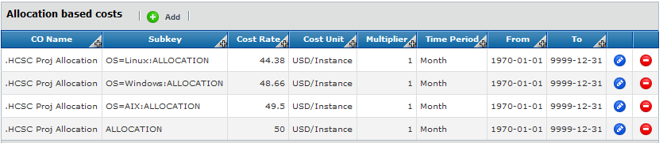
Allocation based costs apply to the nouns present (as opposed to consumed in utilization based items), each server instance in this case. There is a default cost (last on the list with no OS= part), then different cost lines based on what the OS is set to. Each noun will be charged based on the declared OS or at least the default rate. Our manual system accounts for this, so this is a direct replacement. Conditions can be combined to charge for servers differently, than routers, but our models are not that complicated in the manual system or the automatic system. It is important to have a default cost even when all other cases are accounted for. We found many devices that did not have an appropriately defined OS metric (listed as N/A), and ended up with the default cost. This is an unexpectedly helpful data integrity check.

Utilization Based Cost Items
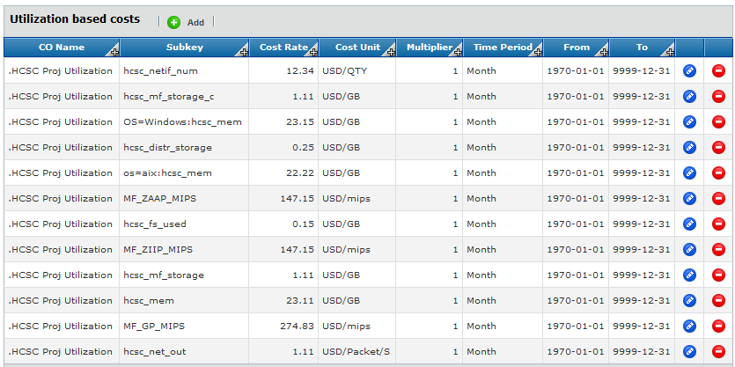
Utilization based cost items are tied to the consumption of the metric in question (as opposed to just present, as in allocation based items). The first line shows that a utilization TYPE charge will be applied to every device that has the subkey of ‘hcsc_netif_num’. The utilization is based on the quantity of network interfaces that are recorded.
The next line is triggered for each device that has the subkey for mainframe storage at some amount per GB assigned. These are items that are assigned to the devices but are utilization type charges. If the subkey is not triggered no utilization charge is applied.
Memory is charged at different rates based on the OS seen (Windows, or AIX) and if OS is not seen, then charged at a default rate. While memory is said to be ‘allocated’ to the device by the server teams, the charge is a utilization based charge in BCO.
The distinction is helpful, and confusing.
Utilization based costs are triggered to the extent a metric is seen, and gives a variable resulting cost. For example, distributed storage is charged 0.25 for each GB reported as assigned, and 0.15 for each GB reported as used. Depending on the number in the metric, the resulting charge will change. These are utilization based charges.
Allocation based charges are triggered when a metric is seen, and gives a standard resulting cost. For example, a device is going to be allocated a charge for an ‘instance’, regardless of how much that instance is used.

There can be many different cost models based on the same few trees and same few basic cost objects. The cost models may have some of the same triggers, but are intended to recover different costs, drive different behaviors, and the models have different missions, so the models will have different values.

Before You Get Started
Generally in BCO, including the chargeback system, the screens are contextual based, which means as you make one choice, other choices are either shown or hidden. These combinations are difficult to see much less understand. It will take some effort and time to get the ‘right’ combination. Count on doing several chargeback efforts before you get one you are happy with. BCO has user groups, documentation, support, consultants and other resources you can refer to for help.
For us, we had a fairly clear idea of what we wanted and a contractor that helped. As we progressed, we realize just how much we don’t know, understand or appreciate about the nuance within the BCO chargeback system. I am sure there is so much more we COULD do with chargeback, and frequently get ‘lost’ in the screens, and what our choices mean to the end results. The available documentation helps, but tends not to directly address our particular use case. When we try to adapt the ‘lesson’ in the documentation, we don’t always get the result we expected. We have a hard time deciding if we did something wrong, mis understood the example, or implemented the example correctly but with the wrong expectation.
All of this is to say, get help. Accept help, set aside plenty of time, and find as much documentation as you can to refer to along the way. Do not expect to arrive at the end result right away. Take small setps. Charge for three things. Then three things based on OS, then five things some based on OS and some based on something else. Trying to get to the end result in one step is more likely to cost you time then save time and effort.

Identify the metrics you will need.
Have the metrics you THINK could be useful in a chargeback system, and make a test grouping of the different types of server that have those metrics and a few that don’t. We found it helpful to make a chart or two, with all the metrics we thought we would use in the chargeback system. This allowes you to evaluate just how universal the universal metrics are. Then we plotted as stacked area graphs. This allows you to compare the billing result with a chart of the same metrics.
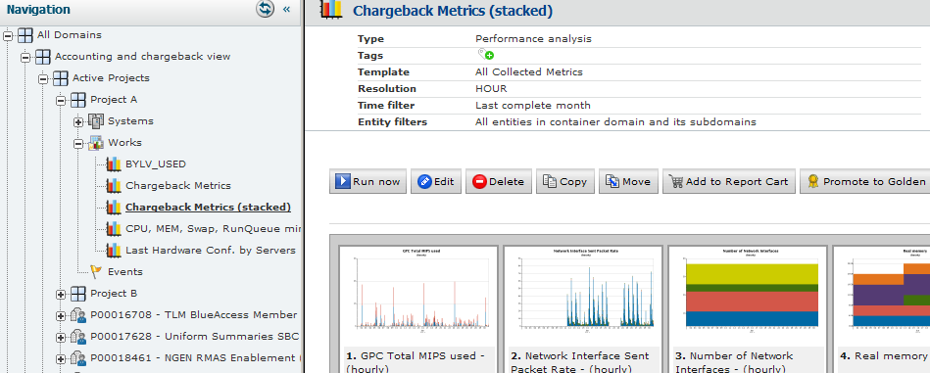

We found that some of our ‘well behaved’ systems resulted in wildly fluxuating charges. Upon investigation, the charges were right. Our understanding of the system, or how the metrics interacted with the charging system, was ‘less informed’ then we originally thought.
The list of metrics also gives a list you will need later when setting up the basic cost objects. We used a hand written table like this. Note that the Metric column is directly from the metric list in BCO.
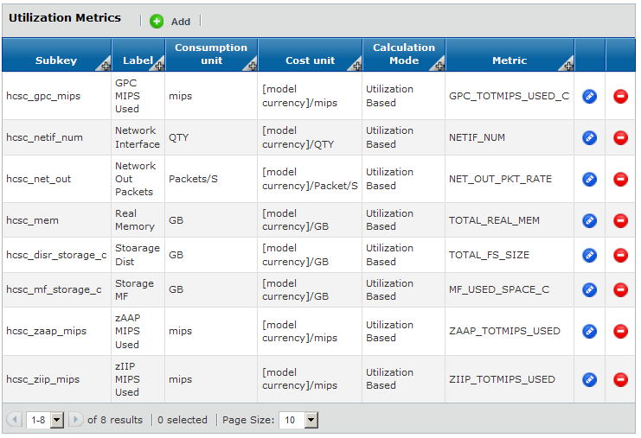

Workspace Tab Preparation
With the end result in mind, we can start making decisions and implement the project chargeback system.
BCO is going to ask us where our chargeback subjects are in the Workspace tab. There are several documents that cautions that the items selected need to be consistently laid out, and have association dates that are appropriate, among other cautions. Our project tree looks like this in the workspace tab.
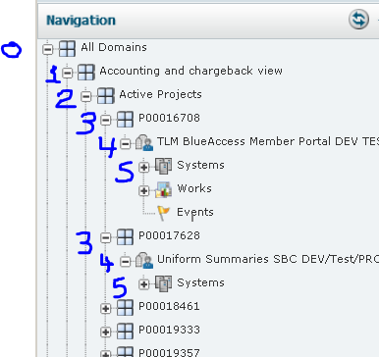
Key to this layout is that the systems (5) are contained in a domain (4) that MUST NOT be included in the hierarchy. This is simple when the layout is consistent. However, if the layout is not consistent then EXCEPTIONAL CARE must be used to keep the hierarchy true and correct, and auto updates are ‘out of the question’.
We want our hierarchy to start at “Active Projects” (2) with individual projects listed under that level (3) (the P number is project accounting codes).
When we rearranged our layout, to support how we wanted the chargeback system to report projects, then our association dates changed (to effective today). So when we ran our chargeback system, no charges were shown for the reports. This is because the rules to incur a charge read something like this. Charge x per hour, for the total_real_mem, assigned to each device, which was assigned to this project, which was assigned to this tree, on this date. When one of those triggers are zero (or out of date) the answer is zero. When you are not aware of this, you will not be able to figure out how a charge is not incurred for a metric that has been on a server, that has been assigned to this project forever, and the project has been around forever. What you know to be true is different than what BCO knows to be true. Look at the dates, when the chargeback system is giving appropriate results for other projects (implying that the basic setup is working).
To sort out the date issues, select the device in question (1), and Hierarchy (2). Check the box for show historical relationships (3). Then check the dates this is assigned to the container domain, which is the project (4) . Note that the next line (5) would not trigger a charge before that date, if you run a chargeback based on the NMON domain. Repeat this for each layer in the chargeback tree (6, 7, 8, 9). When you find inappropriate dates, BMC support should help resolve the issue for your particular situation.
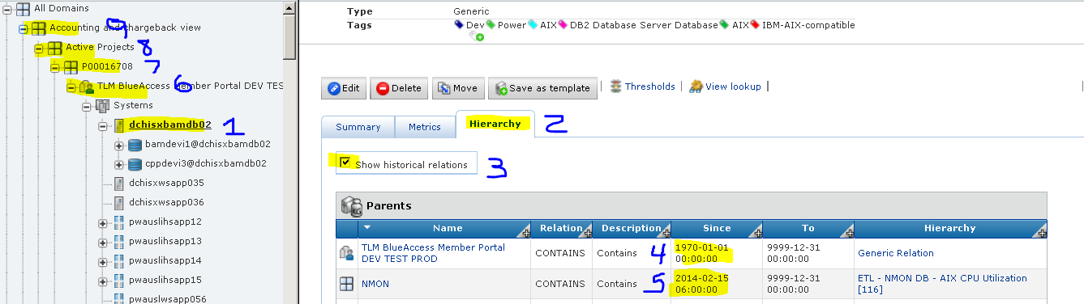

With the tree layout complete, we can start to setup the chargeback system in BCO.

Chargeback for Projects

Goto The Chargeback System
In BCO | Views | All Views | Chargeback | Chargeback – Admin there are several tabs that will contain our chargeback system.
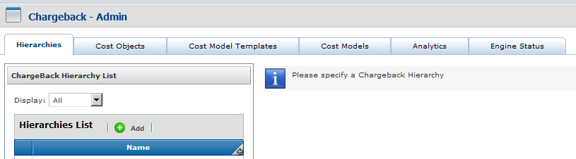

If this is not an option, you must enable chargeback in BCO.
Administration tab | System | Maintenance | Additional Packages | Install chargeback view
BMC has documentation that covers this in more detail.

Hierarchies
On the Hierarchies tab, click Add; give a name and description; and point to our project tree. The name and description can be changed at any time.
We chose ‘Active Project Tree’ as our name, and started at ‘Active Projects’.
We chose Level 3 (default) but see that it includes domains with systems. This MUST be changed for synchronization to work.
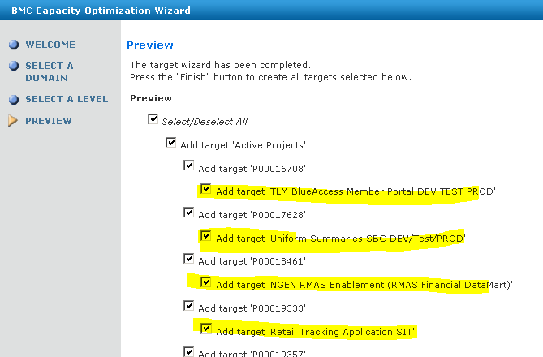
So we went Back, change level to 2, and have what we wanted.
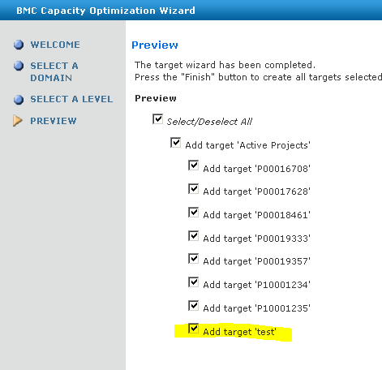
We noted that we see a ‘test’ project that has been removed. This shows up on the list, as the chargeback system is capable of showing chargeback on ‘old projects’.
The ‘synchronize with a domain tree’ option seems to be the most correct answer in our case. Factors we considered are, that everything in this tree is to be included in the chargeback system, and dozens of projects will be added a month. No need to update the tree ‘by hand’. Also, we do not intend to include anything outside of this tree in the active project chargeback system.
Making a limited hierarchy is a manual process to update and maintain, but can be helpful in creating reports that only contain projects of interest to a specific group. Updating the hierarchy must be done carefully as synchronizing will add all ‘missing’ domains (which is probably not what you want) and removing one wayward domin is not doable.

Cost Objects (Basic)
On the cost objects tab, we are faced with our first real choice that will annoy us forever, because there is a compelling reason against whichever you choose. We can crate cost objects based on the fixed rate, allocation and utilization, as our examples shows, OR we can create individual cost objects, that is one for each resource (which means we will have a lot of cost objects).
When you choose to list individual items, you end up with a lot of them to manage and keep track of BUT, the reports ‘look better’ (A). When you choose by function, you end up with only three of them BUT, the report is (will always be) more difficult to read (B).

A
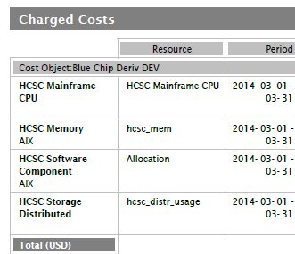
B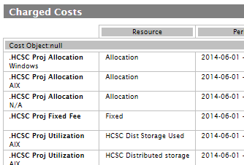

Note that the cost object names show up on the reports, as do the subkeys. Thoughtful use of these labels goes a long way towards making the reports readable. We changed these labels several times, as we reviewed the reports as our customers would read them.
Note that you will need a list of the metrics you intend to use, when you setup your metrics. These are listed in the systems performance metrics section on the metrics tab, and should have been identified when you were making a chart of the metrics (you intend to use) in the chargeback system.
We setup these basic cost objects.

Fixed Rate –
Actually, our ‘Active Projects’ charge model does not (yet) have this concept. The fixed rate is charged to the domain last domain level in the hierarchy tree, and can be used as a ‘project management fee’ or application management fee’. That is to say, a fee charged by the mere fact that the project or application exists. We started testing with $30 per month, but changed to $1 per day in our testing (review how charges are converted to hourly rates for a discussion on the nuance of this). Our ‘final’ model had no charge.
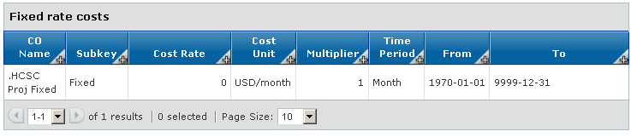

Allocation -
This is an allocation charge that is one for each system. Add a device, take the charge. This is to discourage haphazard adding devices and is used to cover ‘typical’ software installed such as the operating system, scripts, agents, etc. We modify this allocated charge to look for ‘Operating System Family’ and charge Windows and Linux different rate than default allocation.
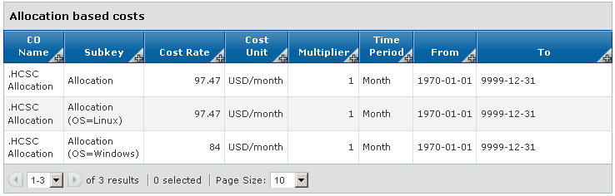

Allocation VS. Utilization –
Allocation and Utilization are confusing terms in BCO vs. how the terms are used by technology groups. While memory is said to be ‘allocated’ to the device by the server teams, the charge is a utilization based charge in BCO. The distinction is helpful, and confusing.
Utilization based costs are triggered to the extent a metric is seen, and gives a variable resulting cost. For example, distributed storage is charged 0.25 for each GB reported as assigned, and 0.15 for each GB reported as used. Depending on the number in the metrics, the resulting utilization charges will change. BOTH are utilization charges in BCO.
Allocation based charges are triggered when a device is seen, and gives a standard resulting cost. For example, a device is going to be allocated a charged for an ‘instance’, regardless of how much that instance is used. This allocation charge will not fluxuate for this device.

Utilization -
Real Memory – This is a utilization charge. The more real memory assigned the more the cost independent of if it is used. This is a cost times the number in TOTAL_REAL_MEM metric for each device.
Real Memory (OS=Linux) – This is a utilization charge just like real memory, but looks for the OS. This distinction allows for fine tuning charges based on other metrics such as, OS as defined by ‘Operating System Family’ metric or environment as defined by the ‘Environment’ metric. This is a cost times the number in ‘REAL_MEM’ metric and modified by the value in ‘Operating System Family’.
Storage Dist – This is a utilization charge. The more storage assigned, the more the cost independent of if it is used. This is a cost times the number in TOTAL_Storage_Assigned metric for each device.
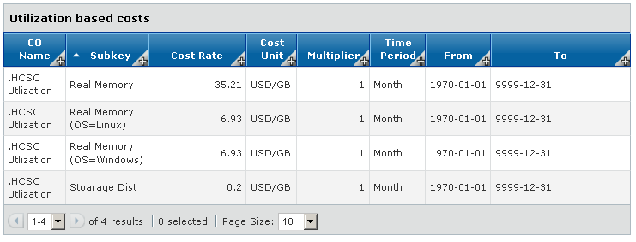

A check of all the chargeback details can be done by querying the database. This makes an audit of the configuration (relatively) simple.
SELECT
AA.*
, BB.NAME
FROM
PV_CB_COST_RATE AA
, PV_CB_MODEL BB
WHERE 1=1
AND AA.MODELID = BB.MODELID
--AND AA.modelid in (10059, 10062)
ORDER BY COSTOBJSUBKEY, FILTER

Placed in a view.
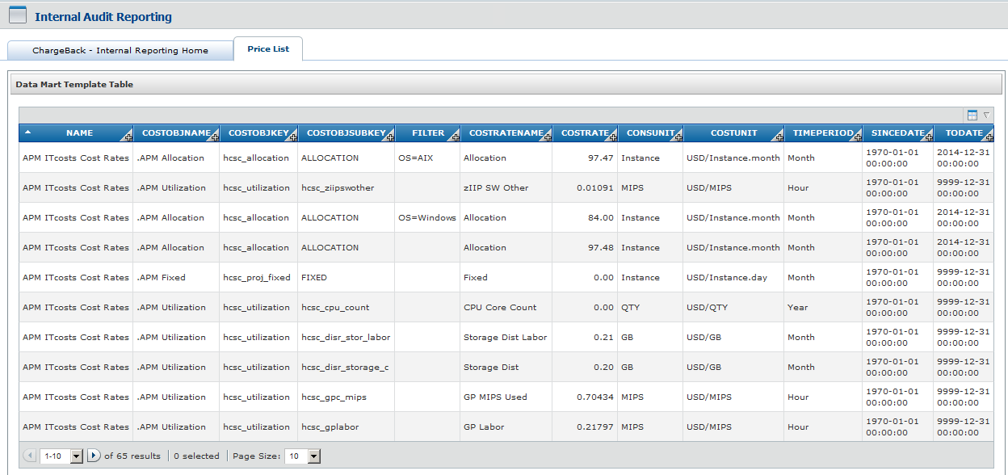

What are the acceptable consunit?
What are the acceptable costunit?
What are the acceptable timeperiod? (Hour, Day, Week, Month, Quarter, Year)

Cost Objects (Composite)
Composite Cost Objects are created when the cost models are run. These are created and defined automatically; so your early builds of a model may not show up.
Filter by cost model templates (1) to see the cost objects that are specific to a cost model. The screen will show that for a specific cost object (2) the details are shown in the right side of the screen (3).
The ‘all’ signal states that the charge is allocated to the cost object entirely, even when the cost object is shared.
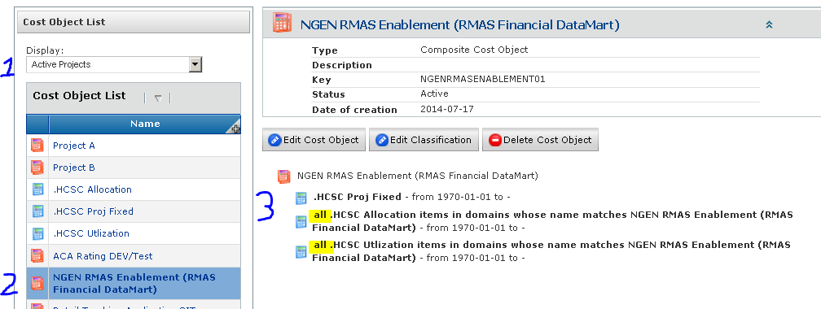

In this case these have been redefined as ‘equal share of’ which will divide a charge when the resource is shared. For example a server is shared by four projects, and this is set to ‘equal share of’ then this project only is charged its share, or 25% of the cost. On any of the other projects if they are set to ‘all’ then each project will receive the entire charge of the resource. So it is important to review the details of each composite cost object.
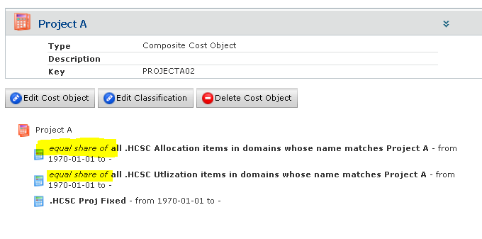
We generally wish that the charges are shared among all the projects that share a resource.
It is not possible with the data we have available to determine which project should be charged for what proportion of the CPU used, for example, as this is not universally recorded in any of the monitoring tools we connect to. So with CPU not recorded in a way that usage could be associated, we chose to use other metrics such as storage and memory.
While this technique is equitable, care should be taken to ensure it is consistently set. Otherwise, one project may get its 25% charge, while the other three projects are each charged full price.
Query to verify settings.

Create Cost Template
The template is created to associate simple cost objects and determine ‘Save Chargeback results as Time Series in Data Warehouse (all Cost Models are automatically promoted to Golden): ‘ ours is set to inactive.
Composite cost objects will be created (when all goes well), and others can be added or removed.

Reports Templates – allows for reports to be scheduled and delivered via email.

Cost model templates can be audited with this query.
SELECT
AA.MODELID
, AA.NAME AS MODELNAME
, AA.DESCRIPTION AS MODELDESCRIPTION
, CC.TARGETID
, CC.NAME AS TARGETNAME
, cc.description as TargetDescription
FROM PV_CB_MODEL AA
, PV_CB_MODEL_TARGET BB
, PV_CB_TARGET CC

WHERE 1=1
AND AA.MODELID = BB.ACBMDELID
AND BB.ACBTARGETID = CC.TARGETID

--ORDER BY MODELNAME, TARGETNAME
ORDER BY TARGETNAME, MODELNAME

Placed in a view.
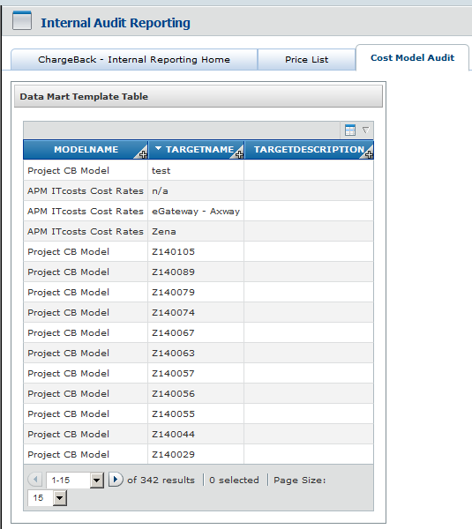

Create a Cost Model
The cost model is where the pieces already defined are stitched together to give cost reports. The cost models are based on a mission or purpose. Based on the mission, a cost model will assemble the pieces to achive the mission. When thre are different missions, a cost model is constructed for each one. The cost model can share a hierarchy, and start in the same place or different place, then combine with the same or different template but each ends up with their own cost rates definitions.
These cost models can coexist and will likely give very different cost answers for the ‘same project’ based on the mission (detail) for the model definition.

Our Active Project Model
For our active projects model, we made these selections:
Add a cost model.
Manual or Service oriented - We chose service oriented.
Base on target hierarchy
Target Parent
Currency - USD, name – Active Project Model, description – ‘’ and finish. . .

As our source tree is expected to update frequently we checked the Synchronized before each run. This takes more time for each run, and can produce different results one ‘run’ to the next, even if run in quick succession, as someone else may have added a project. However, this is desired as in a routine running environment, you want to be sure that all new projects are included.
Our cost model shows the heading information (1), showing what the model is based on. Note that the domain that contains devices (2) are allocated to the target of the project domain (3). An early step in troubleshooting is to confirm that the dates are appropriate in section (4).
Cost rates are viewable at (5) and can be changed. However, changing cost rates should be a rare event.
Then the cost model can be run (6) and the result reviewed (7). Large models can take a lot of time. This sample runs in about a minute.
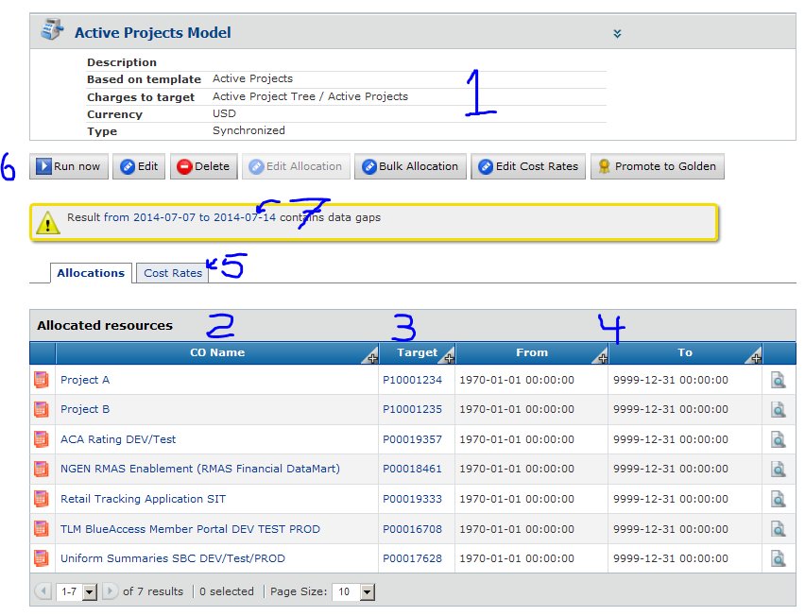

In our early testing we could not get the allocations to work automatically. This was because we included the domain that included systems. This is critical, if you wish for the synchronization to work, the allocations must be automatic. While it was possible to do allocations ‘by hand’ when we had the domains the contained systems in our hierarchy it is very labor intensive and did not allow synchronization. This demonstrated to us the importance of having the hierarchy laid out appropriately and defined correctly. This is the very first step, and when it is ‘wrong’ you will not discover it until the very end when the allocations do not function properly.

If you are having trouble with allocations happening correctly review the hierarchies and tree definitions very carefully. The other steps give ‘wrong’ cost answers but you will still get an answer. The first step, defining the hierarchies, is truly the most important step in this process.

Set Cost Rates
These allocations now need to have cost rates. Each needs to be confirmed or edited in the ‘edit costs rates’ button. We got a result like this.
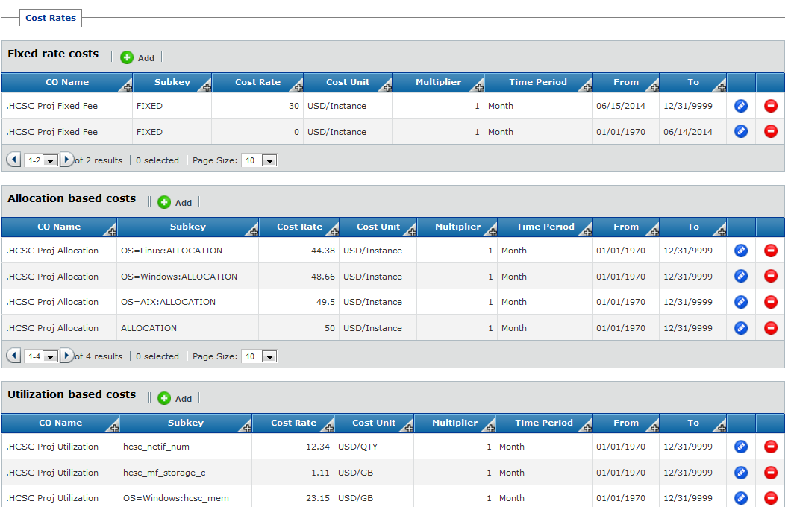

To edit each individual cost rate – click on the blue edit button to the right.
For the three different types of cost make the following selections:
Cost object – select the fixed fee cost object, Allocation based cost object, or Utilization based cost object.
subkey – in the case of fixed cost objects, and for allocation based cost objects - since there are no utilization metrics – the selections will be either FIXED or ALLOCATION. When entering the utilization based costs, a record needs to be entered for each utilization metric selected in the cost objects section.
subkey prefix – in an allocated cost object, this is where you would indicate the trigger for an OS based charge. Entered OS = Linux for example, Allocated cost object will need to be entered once per subkey prefix. (so one for OS = Linux, one for OS = Windows, etc.). The most specific line will be applied to an item. So when the OS metric does not match one stated the generic cost item will be applied. If all had an OS metric defined, and no OS metric matched the item would not be applied to the resource, essentially making it ‘free’.
Time period - which will indicate whether the charge is incurred daily, monthly, yearly, etc.,
Dates from and to,
Cost rate - (per the time period selected earlier)
Multiplier – which will affect the unit price section on the chargeback report. In our case, the multiplier is always 1. (However, the multiplier can be used to manipulate the cost without manipulating what you see on the chargeback reports (section 7, 8, 9 on figure xx)) . This can be used to show the ‘standard rate’ on the report but have a ‘discounted rate’ apply to the charge. Conversely, the multiplier may be greater than one, which results in a premium price (more than the price stated on the report).
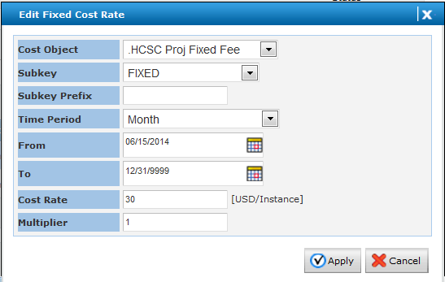

Run the Model and Review Results

The last model run can be seen on the Cost Models tab, however all model runs can be seen on the Analytics tab. These results are equilivent to saying these are pre calculated results, that once clicked on will give a report. Howeve, the reports must still be assembled from this pre calculated result.
There are several built in reports and reports can be customized with the BMC Intretation Studiso, which is out of scope for this document.
However, to ‘audit’ the result, we compared against the chargeback metrics repots made earlyier. This allowd us to compare a day, week and monthly report to the same time span chart result. Exporting to Excel allowed for a summary, multiplication of totals to cost charts and comparing to the chargeback reports.
We found doubious results in the chargeback reports but the reports were confirmed by the metrics reported in the charts. Adjuting prices, metrics to report, and metric modifiers (like OS) are the only real levers available to manipulate the chargeback system. The metrics are facts in evidence in BCO and the price list, once set, is simple math. The math gives a result and the result is going to be right, even if unexpected.
We are trying to mirror an existing system so we compared our results to the manual system and explained differences which were that BCO was more detailed, charging from the day a device was associated with the project, and not missing metrics.

Summary of Project Chargeback System

BCO is a reasonably comprehensive chargeback system that once setup is mostly automatic. We struggled with the chargeback early, and took quite a bit of effort to manipulate the system to mimic our existing chargeback system. The mistake of including the domain that contains systems was a HUGE time sink, but once that was understood and resolved tweaking the system to achieve our desired result was reasonably strait forward.
The real work is to get the tree that you are basing your chargeback hierarchy on is critical. We knew this going in and chose a layout that supported the chargeback system. If we had to rework this on a more established system, we would hve likely just created a separate chargeback tree.
Associating the systems to the tree is another huge effort we factored in early. The BMC Atrium tool doing discovery and placing those assocations in a CMDB that BCO could pull from was a huge contributor. Making these assocations by hand, while outside the chare back system would have killed the chare back system.
Lasstly, the monitoring effort has been actively matured in coverage, consistency and available of data, for several years. Had this effort not been mostly complete, the chargeback system would much more limited and difficult.
In summary, you will likely find the most intensive efforts are in maturing the data for the BCO chargeback system to use (or any chargeback system for that matter), The chargeback system itself is relatively straight forward WHEN the supporting data, and structures are inplace.

Chargeback for Applications
This section is to show how you can leverage work already done on your first chargeback system, into a separate chargeback system with a separate mission.
We focus on the parts that are likely to change and to highlight tools and techniques that we found helpful.

Determine the basis of the heirachy
For our application chargeback system, we need to see how the target applications are arranged in the workspace tab. We see that there is a flat tree (which was done on purpose to help chargeback). This implies we can start with ‘Service View’(1) or ‘BMC Atrium – CMDB’ (2). It is not obvious, but the ‘ BMC Atrium – CMDB’ name starts with a space. This makes it alphabetically first in a few of the menus we are using, and helps distinguish it for the application that is ‘BMC Atrium CMDB’. Howeve this causes problem in matching for searches. While this is a helpful technique, it can create more problems than it solves.

The Workspace Tab…
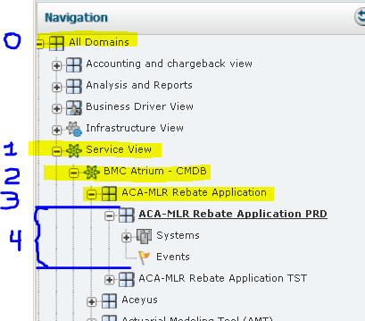

Create the Hierarchy
Add | Name and Description | Follow the wizard
We used BMC Atrium - CMDB as the start and 2 layers - Be careful NOT TO IN CLUDE the layer that has systems.
In the tree we made for applications, we start with the Service View (1) which corresponds to the same level in the Work space tab, then progress to ‘ BMC Atrium – CMDB’ (2). (image above)
We could have started at ‘ BMC Atrium – CMDB’ if we wished, but wanted to include the ‘Manually Created’ applications in our model as well.

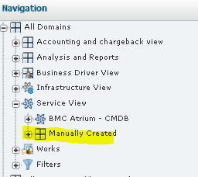

Cost Objects (Basic)
The same issues are present with application basic cost objects as with the project cost objects currently made. The real question is, do you wish to reuse the basic cost objects made for projects in your applications OR make different basic cost objects.
The argument to reuse the basic cost objects is that there are less items to manage, and that any customization such as line item costs must be done in the cost models anyway.
The argument against reusing them is that it is mentally easier to have separate items for separate missions, even when the configurations are materially the same AND you can have different labels on reports.
In our case we chose….
To rename the Utilization and Allocation basic cost objects to be more generic, and use them in both cost models. Changing descriptions is ‘easy’, as this is a database driven application, changing a label does not change the serial number of the item used in the data base, so it continues to work (but should be tested).
We chose to create a different fixed fee basic cost object specific for applications. This was done to chagane the lables that show up on the reports.
Original list
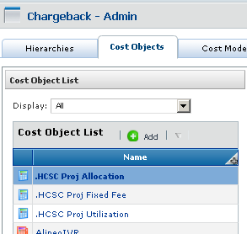

Resulting list
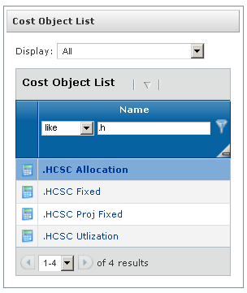

As a consequence of combining the basic cost objects, we should consider which configuration items may need to be included. For example Projects use OS settings in allocation charges, and applications use OS and environment settings, to determine allocation charges. So, we will need to add the environment configuration to the allocations charge items.
Modification made to allocation cost item
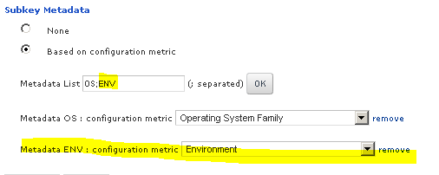

Create Cost Template

The template is ….,

Name , description, not data wharehouse.
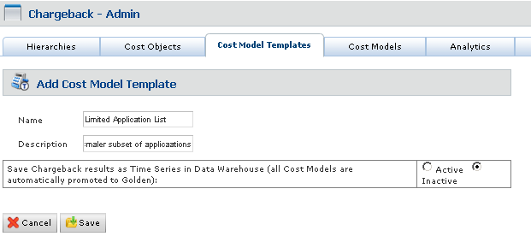

Then add the basic cost objects that are specific to applications…
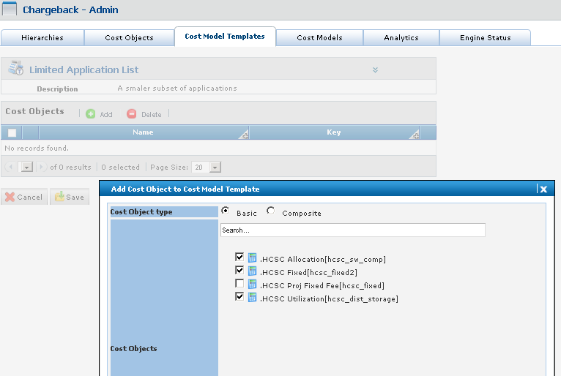

Create a Cost Model

Add a cost model.
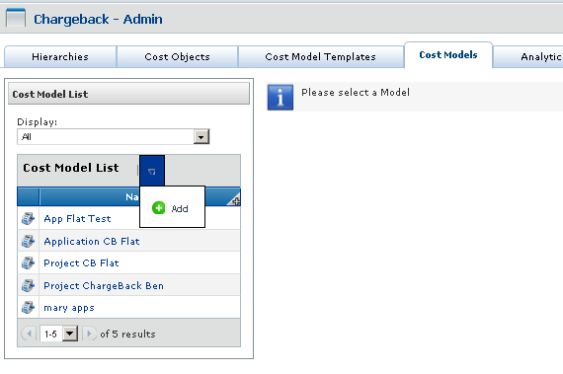

Manual or Service Oriented. We chose service for our Application model as well .
Synchronize or not? We chose to synchronize. The BMC Atrium modeled applications are updated daily and the manually created are changed by a number of people. Synchronizing the model make sure these are accounted for each time the model is run. Again, the hierarchy MUST be laid out correctly or synchronizing will break the auto creation of composite cost objects and essentially break the cost model. Setting this up correctly and NOT INCLUDING the domains that contain systems in the hierarchies is KEY to this working as expected.
Follow the wizard… note that the ‘ BMC Atrium – BCO’ is first because there is a space to start the name.

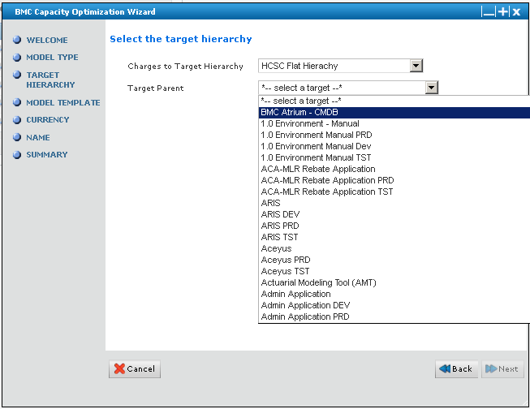

Base on target hierarchy

Target Parent

Currency, name, description, and finish. . .

Now Setup Cost Rates….
The default items are shown so now you need to modify them for this specific cost model. That is to say change prices and triggers such as OS= or ENV= settings

Summary of Application Chargeback System
This should have shown that BCO is a reasonably comprehensive chargeback system that once setup is mostly automatic. While it took some time to get the system working for projects, adapting the system to do application charge back took only a few minutes.
The real effort is outside the chargeback system in getting the data matured for use in the chargeback systems, getting that data into BCO and arranging the project tree, application tree and other trees used in the chargeback system. With that in place the chargeback system is relatively straight forward.
We hope you find this document informative and helpful.

(Question to BMC – delete the template said that all objects will be deleted. This means objects only associated to this template (right)? If shared the item remains?)

Links and Resources
Chargeback for Enterprise
https://docs.bmc.com/docs/display/public/bcmco90/Chargeback+for+Enterprise

Defining and managing cost objects. https://docs.bmc.com/docs/display/public/bcmco95/Defining+and+managing+cost+objects

https://docs.bmc.com/docs/display/public/bcmco95/Defining+and+managing+cost+models
Suggests there is a SOI Name Serice Offering Instance. We do not have one.

…
https://docs.bmc.com/docs/display/public/bcmco95/Defining+and+managing+targets+and+chargeback+hierarchies

Added a cost object on cost object tab.. made one for .HCSC Server Labor specific for APM cost models.

Defined the same way as .HCSC Allocation which now seems to need to be renamed .HCSC Server Allocation

Went to cost model Template. Chose ‘application as discovered’ cost model template. Edit | add| and my .HCSC Server Labor was the only one there. Click Add. This added it, and was confirmed with a fitler view.

Went to Cost Models tab. Select Application as Doscovered | APM IT Costs Cost Rates
Selected Edit Cost Rates. | Add in the allocation based section
Filled out the dialagog box.

Expanding beyond the project charge back model.

We have a customer that wishes to see the cost of EACH application. We have BMC Atrium making the applications and associated servers so this should be relatively easy to maintain.
The basic steps are…
Define the hierarchies
Define the Cost Model Template – schedule reports
Define any new Cost Objects
Define the Cost Models

A mistake we made is that our hierarchy is WAY too big. While this is required for the mission this also then requires us to make the model ‘golden’ which takes the data and writes to the database. While this adds data to the database, and therefore the size it also allows for the data to be queried from a relational database source, not from the XML files and calculated for each report. This is a tradeoff which once made introduced problems.

It seems logical that once this model is in place you can tweak it with other cost models and for other purposes, however, you should avoid this. Instead, you should have a separate hierarchies, template and cost model for each mission. This will allow for each model to satisfy its own mission.
Our two biggest models encompass all discovered applications which we have chose to make ‘golden’ such that they are placed in the database. However, they can be base on the same ‘tree’ but each tree much bedefined separately.

Tradeoffs and Bias
On the one extreme – have one big model that covers all applications in one report. This gives but one hierachie and one cost model/price list. However, this takes a LONG time to run reports and does not lend itself to reporting specific groups of applications (or individual applications), or ‘non standard’ time periods.
For this case the model should be marked ‘golden’ which makes it write to a database where it can be reported against. You now need custom reports and or custom views.

The opposite extreme – have one model for each application in a report of its own. This needs its own hierache (which must be maintained individually) but the hierache will tend to be stable. New applications will need to be setup with their own heirache. However, these should be setup only to the extent that there is a customer for the data. Reports will run reasonably quickly and the built in reports are appropriate, the specific application will be reported upon and non standard times can be accommodated (setting up a report in the Workspace tab).
A change to a price that impacts multiple individual models will need to be set individually.

A compromise position (where no one is happy) is groups of a few dozen applications, based on a static hieriacy (which must be maintained individually) , and price changes that impact multiple models need to be set individually. However, these groupings should be stable in that they are prompted by specific customers for specific purposes.

What should drive the decision?
Work backwards. For EACH REPORT you will need a cost list * target. Cost lists are driven from Cost Models. Cost Models are driven from templates, and Targets. Templates are driven by cost objects (these can be reused?) Targets are driven from Hirachies.

Hirachies can include items that are included in other hirachies but each hirachies should support ONE report mission.

A new mission (as an example)
A customer, the APM (Application Portfolio Management team) has an all-inclusive model, but wishes to create a “Top Ten” report. The applications are so they can more closely monitor the more expensive or sensitive to disruption applications from a cost perspective. To accommodate this request we look at ‘Charge Back for Applications’ section, and create a hierarchies Called “APM Select Apps”; and being careful not to include an application as the first entry, create an APM Select item. Then add the applications requested.

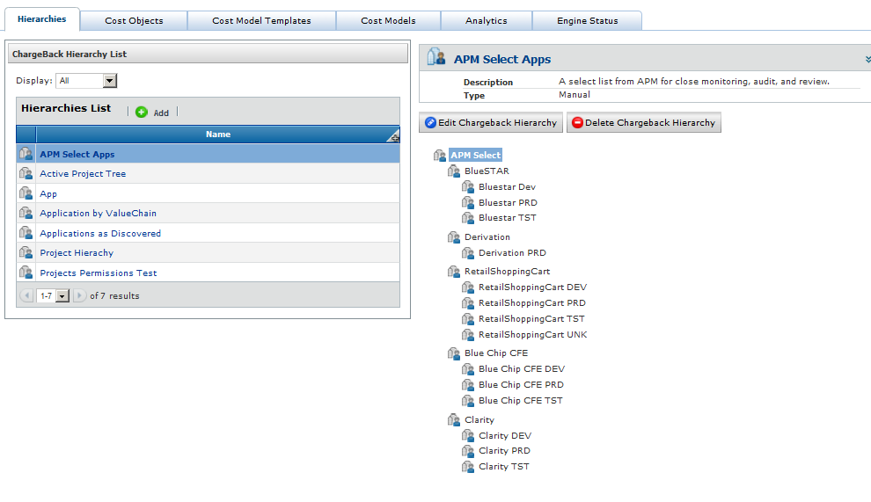

This is a static list, meaning that it must be manually maintained. This is appropriate in this case, as the focus is specifically not ‘everything’, just the items specifically requested. Include all levels of the tree required, In our case the application level and the environment level(s).
As the goal is to report on these separately but exactly the same way as the ‘Applications as Discovered’, we will reuse those Cost Objects.
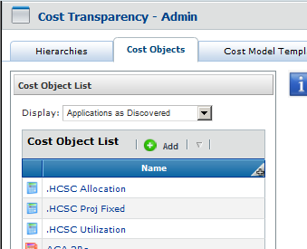

Then add a Cost Model Template “APM Select Apps Template”; add the basic cost objects; add the composite cost objects; then setup any reports. This is a tedious process, as you need to find each composite cost object

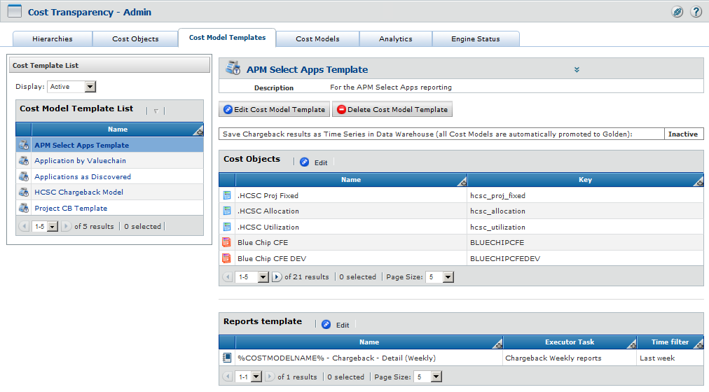
Add a Cost Model – We will make it a manual model.

.APM Utilization
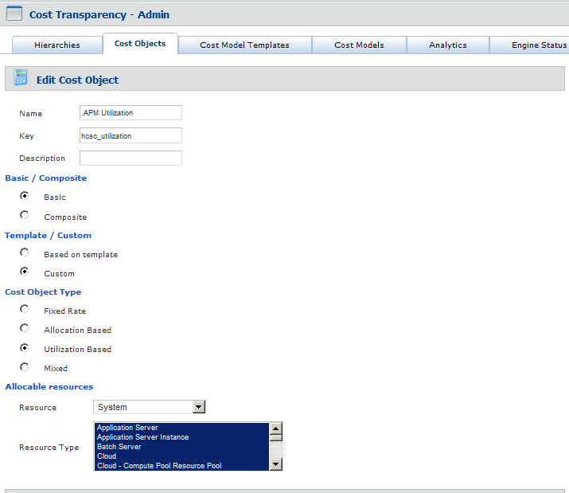
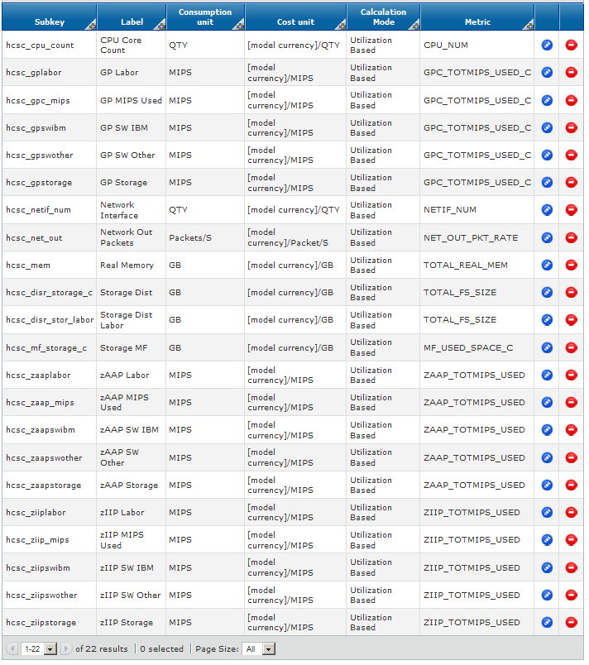
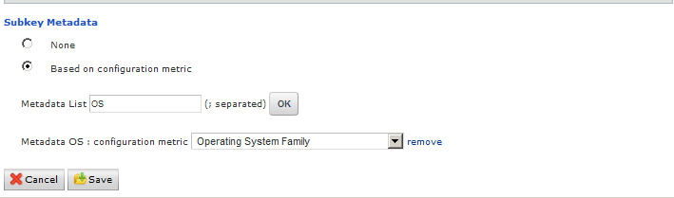

.APM Allocation
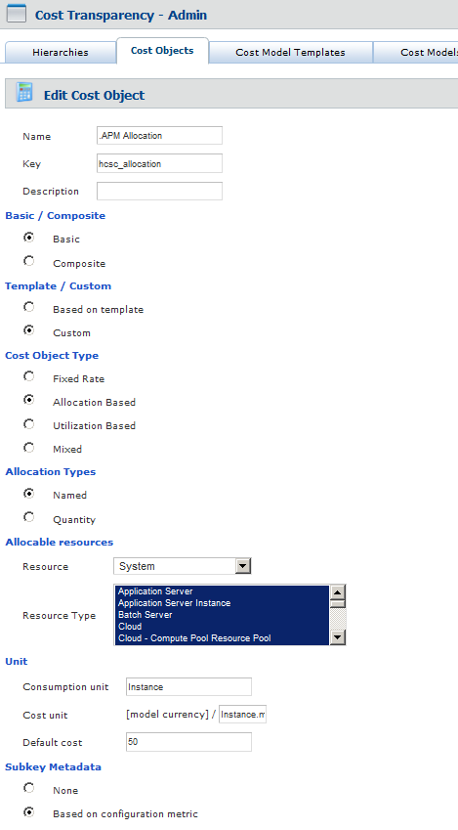
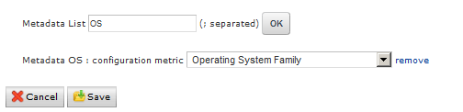

== Charge back CCO set to wrong allocations.
WARNING - this WRITES to the database!!
INSERT INTO ACB_CO_ALLOC_PROPS
(ACBCOALLOCID,NAME,VALUE
)
SELECT ACBCOALLOCID,
'acb.allocationrule.fair.allocation',
'true'
FROM acb_co_alloc AC
WHERE ACBCOSTOBJIDALLOC IN (12186, 12187)
AND NOT EXISTS (
SELECT NULL
FROM ACB_CO_ALLOC_PROPS AC2
WHERE NAME = 'acb.allocationrule.fair.allocation' AND AC2.ACBCOALLOCID = AC.ACBCOALLOCID)

SELECT * FROM ACB_CO_ALLOC WHERE ACBCOSTOBJID = 14027

SELECT * FROM ACB_CO_ALLOC_PROPS WHERE ACBCOALLOCID = 23674
select count(*)
FROM acb_co_alloc AC
WHERE ACBCOSTOBJIDALLOC IN (12186, 12187)
AND NOT EXISTS (
SELECT NULL
FROM ACB_CO_ALLOC_PROPS AC2
WHERE NAME = 'acb.allocationrule.fair.allocation' AND AC2.ACBCOALLOCID = AC.ACBCOALLOCID)

INDEX

A
accuracy 5, 6, 7
application portfolio management 6, 7
application tree 8, 10, 45
B
BCO 5, 7, 5–49, 7, 8, 18, 19, 20, 21, 25, 35, 36, 43, 45, See BMC TrueSight Capacity Optimization
BMC Atrium 7, 36, 37, 38, 43
BMC TrueSight Capacity Optimization 1, 5
C
chargeback 5, 6, 7, 8, 19, 20, 21, 23, 24, 26, 34, 35, 36, 37, 45, 46
CMDB 7, 36, 37, 38
completeness 5, 6, 7
configuration management 7
cost model 13, 15, 28, 31, 39, 43, 44, 47, 48, 49
Cost Models 30, 35, 47, 48
F
fairness 5, 6, 7
I
infrastructure tree 8
O
our configuration management 6
P
per hour charge 8
per resource charge 8
project chargeback 8, 23
R
recovery target 5
repeatability 5, 6, 7
S
shame back See chargeback
show back See chargeback
W
work backwards 10, 49

